
ZHEJIANG GEELY AUTOMOBILE CO., LTD.
NO.1760, JIANGDONG ROAD, HANGZHOU, ZHEJIANG, 310051
CHINA
TEL: +86-571-2809-8618


GSO Conformity Certificate CCR No. 867011
Motor Vehicles
Manufacturer: Zhejiang Geely Automobile Co., Ltd
Country of Origin: CHINA, Country of Production: CHINA
To: GCC Standardization Organization (GSO)
We hereby certify that the vehicles manufactured by Zhejiang Geely Automobile Co., Ltd
* Type: Geely Cowboy 1.5L Turbo SUV FWD 5 Doors
* VlN number: L6T7722Z*S*******
* Model Year: 2025 * Produced in and after: Month 8 Year 2025
* Category: SUV
Will satisfy the G50 Technical Regulations Nos: 34:20o7, 3s:2007, 36:2005, 37:2012, 38:200s, 392005, 40:2011,42:2015, 48:1984, 51:20o7, 52:2007, 53.2007, 9611988. 9721988, 9811988, 9921988,13522007, 13622007. 29021994. 4119:1994,42o:1994,421:2005,422:200s.1040:20001041:2000,1042:2000,1053:2000,1503:2010,1598:2002,1624:2002,1677:2003,1708:2o0s,1780:2010,1781:2006,1782:2008,1783:2006,1784:2o0e.Gsolso1585:2008,GSO lSO 3537:2008, GSO 150 3538:1997, G50 ECE13H:2012,GSO ECE13H-1:2012,GSO ECE13H-2:2012,GSO ECE 13H-3:2012, GSO ECE13H-4:20l2, GSO ECE13H-S:2012,GSO ECE 13H-6:2012 and the standards in the country of origin accepted by GSO in the case that no GSO technical regulations and standards are available.
All the essential technical data are as follows:
1. Weights
a. Maximum Vehicle Weight: 1815 kg b. Curb: 1450 kg
c. Maximum Axle Weight: Front: 900 kg Rear: 915 kg
2. Dimensions
a. Length: 4518 mm b. Width: 1834 mm
c. Height: 1715 mm d. Wheelbase (Fl R1) 2660 mm e. Track: Front: 1560 mm Rear: 1560 mm
3. Type of chassis and body: Monocoque
4. Number of Passengers: 5(Including the Driver)
5.Engine: Petrol a. Cylinders: 4 b. Displacement: 1499cc c. Air intake: Turbo
d. Net Engine Power: 128 kW at 5500 rpm Pollutant Limit comply with Euro 4.
6. Transmission: Automatic
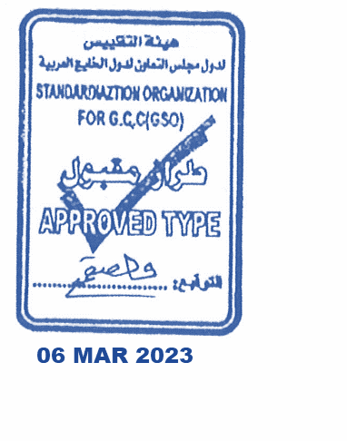
7. Brakes a. Service Brakes: Hydraulic b. Emergency Brakes: Combined with the service brake
8. Fuel Economy a. Motor Vehicle Class: SUV b. FE (CAFE) Combined: 17 km/L - Excellent
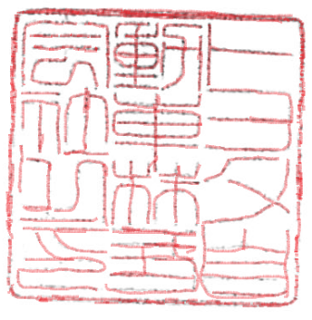
9. Any other information or local standards to be compiled: Also comply with the National regulations for member countries mentioned in the Annex of the list of Technical Regulations for MV 2025 MY-D5, when exporting to those countries..
Keiko Yanagi
general Manager Regulation &Certiﬁcation Division
11 OCT 2025

